思 恩 中 醫 慢 性 病 治 療
TCM for Management of Chronic Conditions

Chronic disease is one of the most pressing health issues facing individuals, and Singapore, today.

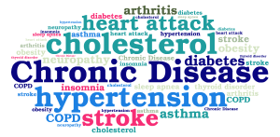
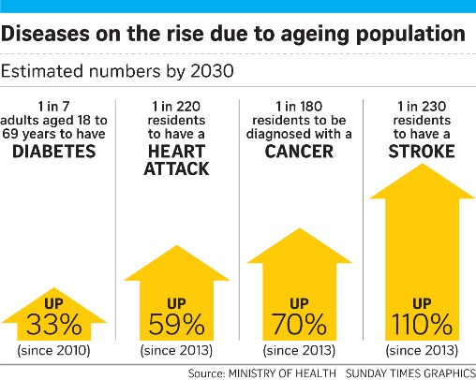
The principles of TCM and its approach to disease prevention and management hold the potential to do so, said Health Minister Gan Kim Yong on Sunday (2016, Oct 23). "Acupuncture, for niche areas like pain management and stroke rehabilitation, is now available at public hospitals, an important step to a more holistic approach to patient care," said Mr Gan.

Si En’s TCM restores health and balance by treating illness and disease through acupuncture, Chinese herbal medicine, TCM nutrition and dietary therapy and tuina for:

- Chronic respiratory conditions / 慢性呼吸系统疾病，例如哮喘，和慢性阻塞性肺病
- Chronic skin conditions / 干燥症, 干癣，脂漏性皮肤炎，异位性皮肤炎和银屑病
- Chronic reproductive disorders / 不孕症调理
- Chronic digestive disorders / 消化系统疾病如消化性溃疡，胃肠机能障碍
- Chronic Pain / 慢性骨关节疾病, 慢性疼痛, 偏头痛
- Allergic Conditions / 过敏性疾病：如气喘、过敏性鼻炎，自律神经问题等
- Post-stroke rehabilitation, treatment intervention & recovery management
中风患者之中医药治疗与保养

SI En Medical offers TCM treatment options which are tailored to suit your needs by constantly assessing your response throughout the course of treatment and updating the program accordingly to ensure the best outcome for you.

Contact us today for a consultation session with our friendly TCM Physician!
Getting quality medical care in Singapore has never been more convenient.

https://www.straitstimes.com/singapore/health/tcm-can-play-role-in-meeting-healthcare-challenges-of-ageing-population-gan-kim (2016, Oct 23)

